

Bergecco-Parc Consulting Inc. Presents their Proposal for:
“Critchley’s Candies: We’re Making it!”
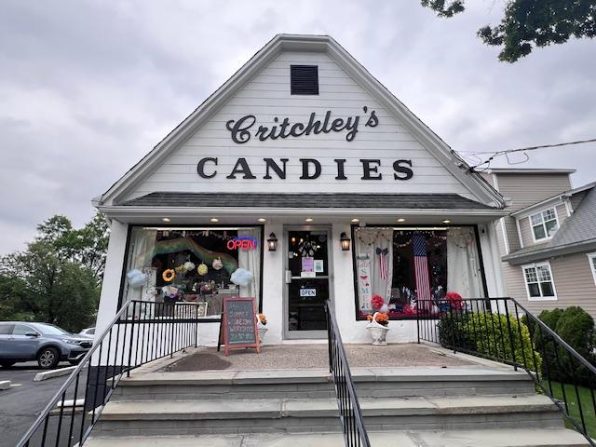

The Project Proposal: “Critchley’s Candies: We’re Making it!”
Welcome Team Member to Bergecco-Parc Consulting Inc. one of New Jersey’s premier boutique marketing firms. The firm wants to welcome you to the Paramus, NJ satellite division of the company. Our New Brunswick Headquarters is excited about this opportunity to work with Bergen Community College located in Paramus, NJ.
History of the Company:
Bergecco-Parc Consultants Inc. is a consulting company founded in New Brunswick, NJ in 1999 by a group of Rutgers Graduate Students. The students were hired by the university after their graduate project won a marketing contest for the campus’s ‘Homecoming 2000’ event. The project won over many well-known marketing firms as having the pulse of what university students need to know about the happenings on their campus. The firm has continued to grow, and the headquarters is still in New Brunswick, NJ.

The Consulting Team Project:
Critchley’s Candies at 812 Kinderkamack Avenue of River Edge, NJ has asked us to collaborate with them to help them promote their business and their wonderful selection of candies and chocolates. The store has just come under new ownership, and we have been tasked with promoting their business for a new customer base while engaging their current roster of customers.
Status: We have just hired more people to expand our Executive Team in Paramus, NJ and are looking to expand our efforts into Bergen County and by winning this bid will give us a prominent foothold into the most populated and wealthiest counties not just in New Jersey but in the entire country. This promotion with Critchley’s Candies is one of our first with an Independent Owner store.

Company Logo:

Motto: Growth comes from Within (based on the six founders of the company)
Proposal: Critchley’s Candies
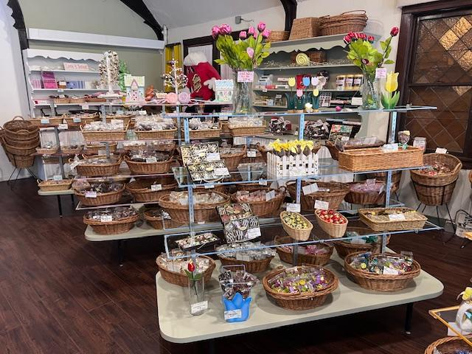
Critchely’s Candies has proposed a retaining fee of $10,000 (this is not the budget) for our services and the store owner has proposed a series of ideas that need to be expanded upon:
Ideas that have been proposed:
Marketing Team:
- Creation of a new logo: The owner has just created a new logo but asked for some other ideas. We need to produce one or two proposals based on her current logo.
- Creation of a snappy title to match the name: The owner would like a snappy jingle to match the name of the store. Something creative that people will remember.
- Commercials: We have proposed two commercials for YouTube and Tik Tok:
- History of the store and interview with the owner: The owner would like a personal interview discussing the history of the store and its place in the community.
- Promoting the store to the public: The owner would like an engaging commercial shot in the store with music promoting both the store and the new line of homemade candies. Something fun and a song you can hum to after watching it.
Events and Product Development:
- QR Codes for the Candy Assortments: The owner has asked us to create a series of QR Codes to tell customers what is in their assortment boxes.
- Proposal for a Care Package to Summer Camps: With the summer coming, the owner would like to set up a Care Package for online shipping. Please put a proposal together with current assortment in the store and price out a care package of candies that you think campers between ten to sixteen years of age might want to receive. Please use one of the new logos for the packaging.
- Proposal for an in-house birthday party: The owner has gotten requests from customers to hold birthday parties in the store. Please put together a package with balloons, music, and a cake plus a goodie bag from the store with its wonderful candies and price this out. You will need to find a bakery for the cake and what balloons and party favors might cost.
- Promotion of Handmade Inhouse candies: The owner has developed a new line of candies. She wants to create a promotion on this. You need to produce a few ideas on how best to let the public know of these delicious homemade candies.

The History of Critchley’s Candies (from their website):
For those new to Critchley’s Candies, our building’s origin was a former Grace Lutheran Church. If you look at the back of the store, you will see a decorative arch. This is where the original alter was in place. The building was converted to a chocolate and candy shop in 1957. Nicholas S. Phillips, and later his brother Ed, were two of the original owners. They trademarked the “Mint Oritani” which was at the time our most famous treat!
The store has changed ownership a few times over the decades, but each time it has kept the traditional chocolate recipes and added new delicacies. Critchley’s has become a one-stop shop with its expansive selection of gifts. Of course, there are still the old favorites like our wide selection of chocolates, licorice, gummi bears, delicious chocolate covered strawberries and our newest favorite… hot cocoa bombs!
Divisions in the Paramus, NJ Satellite campus:
CEO/Co-Founder: Professor Justin Watrel is the CEO/Co-Founder of Bergecco-Parc Consulting Inc. and will be working with headquarters in New Brunswick, NJ to report all information on the proposal. He will be collaborating with ALL members of the team with the President and Senior Vice-President of Operations reporting to him. All communications got through his campus email Jwatrel@Bergen.edu. He will hold weekly board meeting to check on progress on the operation.

Divisional President: The President runs the whole operation of the Satellite Division of Paramus, NJ for Bergecco-Parc Consultants Inc. You and your Senior Vice-Present of Operations will be responsible for:
*Running the Power Point the afternoon of the Presentation (gathering all the information from your teams).
*Communicating with your Divisional Vice-Presidents and Team Leaders and keep an open dialogue amongst the teams.
*Work with the Vice President of Operations on the Power Point Presentation and the company website that will be set up with all the information gathered. This will include all information on the project with pictures, company proposals and vendors.

Divisional Senior Vice-President of Operations: The VP of Operations will be collaborating with the President on all aspects of the project:
*Collaborating with the Vice-Presidents and Team Leaders to be sure everyone is doing their assigned work.
* Working with all budgets: the $10,000 retainer is not the budget. It is the amount of money for us to study the project and pay for services and salaries while we are running the operation. The budgets are determined by the research and prices that are needed to run the event and submitted by each team.
*Work with the President to film the presentation of the program for YouTube and work on the Power Point Presentation.
*Work with the President on setting up the website on the project and making it live on Google. Please investigate Wordpress.com to set the site up.
Since we are under a time constraint and need to get this project done in a two-week period, the President will be working with the Marketing Team and the SVP of Operations will be working with the Events and Product Development Team. They will be doing this while working on the PowerPoint and the Website.
All the work must be completed for the PowerPoint by June 20th so that the PowerPoint will be ready for the June 24th presentation.

Positions with the Two Teams:

Vice-President of the Team: The VP of the team will run the operation of the team and work with their Team Leader and Team Members to put together their section of the proposal and the Power Point Presentation. All three Vice-Presidents will work together to make sure all the work is coordinated on a timely basis and will report this back to the President and the Senior Vice-President of Operations.
Team Leaders: Team Leaders are the “Right Hand Man/Woman” of the Vice-Presidents and will assist them and their team members with whatever assistance they may need. They will assist with all budgets and creative ideas. Team Leaders from all divisions can assist each other with information another Vice-President may need.
Team Members: Our life blood of the teams. You will assist in gathering information, setting up budgets and work with the Vice-President and Team Leader to promote TEAMWORK on your team.
Everyone has a job to do, and everyone must participate!

The Divisions:
The Marketing Division:
- Creation of a new logo: The owner has just created a new logo but asked for some other ideas. We need to come up with two or three proposals based on her current logo.
- Creation of a snappy title to match the name: The owner would like a snappy jingle to match the name of the store. Something creative that people will remember.
- Commercials: We have proposed two commercials for YouTube and Tik Tok:
- History of the store and interview with the owner: The owner would like a personal interview discussing the history of the store and its place in the community.
- Promoting the store to the public: The owner would like an engaging commercial shot in the store with music promoting both the store and the new line of homemade candies. Something fun and a song you can hum to after watching it.
The Special Events & Product Development Division:
- QR Codes for the Candy Assortments: The owner has asked us to create a series of QR Codes to tell customers what is in their assortment boxes.
- Proposal for a Care Package to Summer Camps: With the summer coming, the owner would like to set up a Care Package for online shipping. Please put a proposal together with current assortment in the store and price out a care package of candies that you think campers between ten to sixteen years of age might want to receive. Please use one of the new logos for the packaging.
- Proposal for an in-house birthday party: The owner has gotten requests from customers to hold birthday parties in the store. Please put together a package with balloons, music, and a cake plus a goodie bag from the store with its wonderful candies and price this out. You will need to find a bakery for the cake and what balloons and party favors might cost.
- Promotion of the Handmade Candies: Commercials on Tik Tok and YouTube.

Budget:
We are working with a proposed $10,000 retainer that is NOT the budget. The budget for this event will be created by the teams on the research they gather and then presented to the town.
*The owner of Critchley’s Candies wants to hear from us as well. What other ideas do the teams have to enhance, modify, or add to promote the store? She would like to hear extra proposals from the team.
*Remember nothing is engraved in stone. If you think of changes, please run them by me first.

The Paramus Satellite Executive Team:

CEO/Co-Founder:
Professor Justin Watrel Jwatrel@Bergen.edu

President:
Peter McNamara* pmcnamara139481@me.bergen.edu

Senior Vice-President of Operations:
Jc Abella* jabella141816@me.bergen.edu

Vice-President of Marketing:
Ryan Mastofilipo rmastrofilipo@me.bergen.edu

Team Leader of Marketing:
Ammar Alnaggar aalnaggar@me.bergen.edu

Team Members of Marketing:
Heshan Obaid hobaid@me@bergen.edu
Matthew Marques mmarques160156@me.bergen.edu
Daniel Durso ddurso164801@me.bergen.edu
Kimberly Perez kperezpineda@me.bergen.edu
Seyed Alemohammad salemonhammad162363@me.bergen.edu

Vice-President of Events and Product Development:
Joel Fife jfife@me.bergen.edu

Team Leader of Events and Product Development:
Liam Vime-Olive lvimeolive@me.bergen.edu

Team Members of Events and Product Development:
Benjamin Folignoni bfolignan@me.bergen.edu
Robert Reiman rreiman@me.bergen.edu
Aisha Martinez amartinez132609@me.bergen.edu
Stephen Parkin sparkin@me.bergen.edu
*Since we have a small Team this semester, the President will be assigned to help the Marketing Team and the SVP will be assigned the Special Events Team on top of their responsibilities of the PowerPoint and Website creation and running the Presentation on June 24th, 2025.
Dress Code:
Bergecco-Parc Consulting Inc. believes that a well-dressed employee shows the most professionalism. Ladies and Gentlemen working with Ladies and Gentlemen.
Ladies: Please follow Dress Code: A dress or Blouse & Skirt/Layered look with vest or sweater, Business Suit or Slacks with Blouse and Jacket/Vest or Sweater. Conservative jewelry and either flats or pumps. Please be sure that your shoes are shined. Professional hairstyles.
Men’s: Please follow Dress Code: A suit with tie, a Jacket with tie and slacks, if you do not own a jacket, please slacks with a button-down shirt and sweater (tie optional but preferred). Conservative jewelry and conservative shoes. Please be sure that your shoes are shined. Please either grow all facial hair out or come clean shaven. It is for one day everyone.
Grading: Teamwork is the rule of this project and is taken very seriously. Once a team is assigned, the TEAM will be dividing up their work with the VP and Team Leaders collaborating with their team members on their section of the project.
You all will be graded as both as a team and as an individual. It will be based on:
*Your Team and Your Personal Presentation (Everyone will be talking that night)
*Dress Code
*Creativity in the ideas and in the project
*Final Paper you will be writing on the project

Research Paper: Paper Four:
This will service as your last paper of the semester. What did you learn from this project:
What did you get out of the project? How do you look at Bergen Community College differently now? How well did you collaborate with your team? We do not pick who we work with in life, so you were put with people you do not know. How well did you get along? Did the team work effectively? What would you have done differently? What were your insights on the team itself? I want to hear your insights on teamwork.

The Presentation:
You will present the project to myself and all invited guests (you can invite family members as well). You as a class will decide how to present it. It could be poster board, Power Point, slides, etc. The last class used Google Slides for their presentation.
Any type of promotion you want to use to promote your areas must be approved by the President, Senior VP of Operations, and the Vice-Presidents. Please consult with your CEO as well.
This project will require field trips out to some of the sites during class time so the Professor will allow travel time for those attending classes before and after our own. It will also require you all to visit sites on your own time as homework and research to the sites. Failure to attend the field trips without being excused by the Professor will be considered an absence and your class & group project grades will be marked as not attending and will hurt your grade on the group project. This will result in a full grade deduction in the project.
Remember to take your work with the company very seriously. Not doing your job and non-participation leads to termination from the company. Termination means you fail the project. This is almost 50% of your grade so please take your role in the company seriously.
The project is going to be presented Tuesday, June 24th, 2025, and the paper will be due Monday, June 23rd, 2025. All final work must be into the President and SVP of Operations no later than June 20th, 2025 to set up the PowerPoint Presentation. Failure to show up for the presentation to show your work MEANS YOU FAILED the Project!

Please remember that how the project and presentation go will determine what type of Final Exam that you will have at the end of the semester.

Please remember this is what will happen in real life with a proposal at the last minute that could bring big profits into the firm so take it seriously!

