Coney Island Luna Park: Lights, Excitement and Action by the beach: Customer Relationship Management Paper

Amal Alahdal
Ali Alghamdi
Jiacheng Lu
Khalid Qutaym
Catherine Shi
Justin Watrel

Executive Summary:
The Team had site visits to Luna Park starting with a formal tour with the park’s Operations Manager, Bryant Alberto in September and we walked the entire park. While there, he discussed the company, the amusement selection, the target market, a family friendly park with lots of park engagement and the promotion of new events, Harvest Fest, and the current Frost Fest. Part of the park’s promotions as well will be fireworks and movies on the beach. They work in coordination with the Coney Island Alliance on these. The park is currently reviewing its food service as well.

From this visit, each of us took a tour of the park on our own, some of us multiple times to experience the park and while we had a nice time there were issues that needed to be worked on:

- Social Media Marketing: The park’s social media sites of Facebook is not active enough. The park needed to post more on Facebook, Instagram, and YouTube for more active engagement with target market. They also need to partner more with City DMO New York City Tourism+Conventions on their theme events. There was no mention of “Frost Fest” the City run site, which reaches a wide audience of tourists both domestically and internationally. They need to continue to work with the Coney Island Alliance. It is important to get the word out on all park events.
- Service Quality: Customer service is key in family friendly park. The park needs to put together a team member training program for its staff that is consistent across the park on all rides, foodservice, and security. This will keep the service level consistent with client relations throughout the park.
- Feeling of Safety and Security: The park has three entrances and is broken up into three sections which can be daunting for park security. There are open entrances from the public Boardwalk so there needs to be a consistent security presence throughout the park with guards dressed accordingly to promote a safe, family friendly environment. The park should post safety inspections of rides as well.

Luna Park is a family friendly park with a lot of great attributes but needs some work on making that engagement consistent through park while catering to a out of town domestic and international customer. The park employees need to be trained that every guest is not from Brooklyn and when guests visit give a consistent image of who the park is and how they want to be perceived by those guests. They also need to work on their Social Media plan to attract the target market they are seeking.

Introduction and History of the Park:

When the name “Coney Island” is discussed by tourists both domestically and internationally, many images come into play. The idea of ‘fun in the sun,’ exciting rides, lots of music and the smell of hot dogs and French fries. The reality is that is the Coney Island of the past and while the current rides and attractions still attract large crowds of people, it is now on a much smaller scale than the turn of the last century.
Coney Island is only five miles long by three quarters wide and is located on the southwestern end of Long Island. The island has an east-west direction of the beach so the sun shines on Coney Island all day. It was not until 1829 when the Coney Island House opened a summer vacation hotel bringing weary New Yorkers down to the beach for a new thing called “sun bathing”. The creation of the five-day work week in the 1900’s created weekend outings and Coney Island became that destination. With the crowds came the building of other hotels, bathhouses and pavilions for people who were looking for relief from the heat of New York City tenements (Kyriazi, Gary “Great American Amusement Parks” 1971).
With these gentle amusements such a pleasure gardens and summer bathing the creation of amusement rides as an extra attraction starting with the Sawyer Observatory, renamed the Iron Tower, that came to Coney Island in 1877 from the Philadelphia Centennial Exposition. Then in 1884, the first roller coaster came to Coney Island from inventor and teacher LaMarcus Thompson with his “Switchback Railway, a series of dips and swings around an elevated platform and with these two amusements started the great innovation and invention of modern-day rides and Coney Island was known as an ‘incubator’ for modern day amusement parks (Kyriazi, Gary “Great American Amusement Parks” 1971/Research Paper Justin Watrel Senior Thesis-Hunterdon Central HS 1983).
Luna Park has an illustrious history in the era of the modern amusement parks. Part of the ‘great three’ amusement parks of Coney Island, Steeplechase Park (1897), the original Luna Park (1903) and Dreamland (1904) these parks were considered at that time and even today as the great innovators of the modern amusement parks such as Disneyland and Six Flags Great Adventure. Each vied to get most thrilling attractions, the most lights, the highest towers, and spirals and foremost, the most laughter and enjoyment.
The original Luna Park opened in Coney Island in 1903 as the second of the three great amusement parks that included Steeplechase Park and Dreamland. The park was opened by Fredrick Thompson and Elmer Dundy after their successful ride “A Trip to the Moon,” was moved from the Buffalo Exposition to Steeplechase Park in 1901. When the contract ended in 1902, the partners bought the defunct Sea Lion Park and turned it into Luna Park (Kyriazi, Gary “Great American Amusement Parks” 1971).
The park was known for its soaring minarets, spires, domes, ornate architecture, and monumental buildings covered by 250,000 electric lights. When the park opened, it featured some of the most innovative rides that Coney Island had ever seen that included “A Trip to the Moon,” “Chinese Theater,” “Fire and Flames” and “The Streets of Delhi.” It was one of the most creative amusement parks of its era and many new innovative rides that many modern amusement parks were patterned after (Kyriazi, Gary “Great American Amusement Parks” 1971).

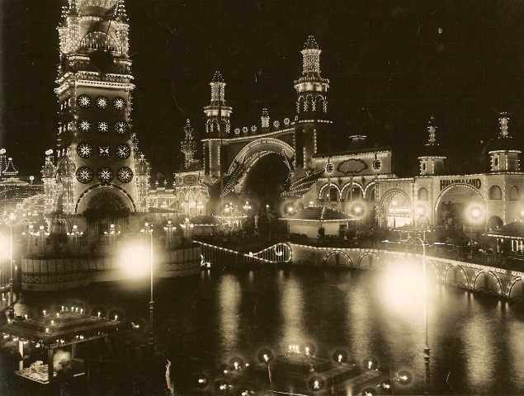
The inside of Luna Park (1903) (New York Historical Society)
With the death of Elmer Dundy in 1907, the park started to have financial problems and with the death of Fredrick Thompson in 1919, the park was taken over by a group of businessmen who had little interest in the park. The park was left to slide until two renovations in 1935 and 1941 but it did little to bring the crowds back. There was a great fire in the park in 1946 and the park closed permanently and became a parking lot. The site was eventually turned into apartment buildings built by Fred Trump (Kyriazi, Gary “Great American Amusement Parks”).
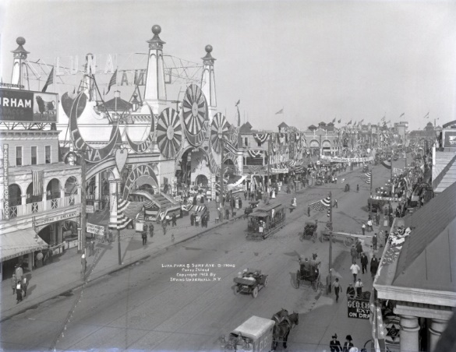
The original entrance to Luna Park (1903) (New York Historical Society)

The current Luna Park is located on the site of the former “Astroland Park” that had opened in 1962 and was opened with a “Space Age” theme and most of the rides were considered ‘carnival rides’ catering to children and families but the park ran the famous Cyclone roller coaster, still the most popular ride on Coney Island. Astroland closed in 2009 and demolished and the currently Luna Park opened in for the 2010 summer season over Memorial Weekend (Wiki-Astroland history).

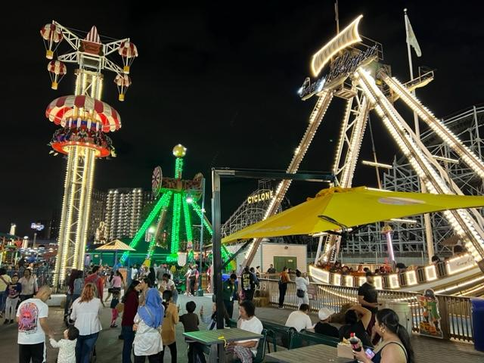
Luna Park October 2023

About the Business:

Luna Park today was redeveloped by Central Amusement International of Boonton, NJ whose company background includes 150 years of amusement park experience and is a park planner, developer, and operator. The company is owned by Zamperla family lead by Alessandro Zamperla, the current CEO/President. In 2009, the company construction of Luna Park with rides and attractions. The company also added 8000 LED lights to the famous Parachute Jump, once part of the original Steeplechase Park and run the historical B & B Carousel, owned by the City of New York, in Luna Park (CAI LinkedIn/website).

Founded on the principles of providing a thrilling experience in a family-friendly environment this is entertaining and engaging, Luna Park wants to captivate guests of all ages. Recently adding two new thrill rides: Luna 360, the Thunderbolt Roller Coaster and the Endeavor, the park continues to embrace new technologies, updating attractions and introducing new entertainment options to keep up with changing trends and visitor preferences.

The business often engages with the local community through various initiatives, events, and partnerships, fostering a positive relationship and contributing to the cultural and economic fabric of the area that it operates.

(CAI website)

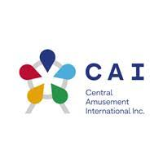

The CAI logo-CAI website.

The role of the Customer Experience to the concept of Customer Relationship Management in the business:

The Customer Relationship Management (CRM) Strategy that establishes and maintains good relationships through effective customer interaction. CRM is meaningful for the personalized experience, marketing and promotional activities, customer loyalty enhancement, customer interaction and complaint management in the operation process of Luna Park and helps to grow the customer experience and promote business success.

In the absence of a formal Customer Experience Strategy or Loyalty Program at Luna Park, the discussion regarding the role/importance of the customer experience to the concept of Customer Relationship Management and Loyalty becomes more generalized but remains critical to the success of their business.

The Customer Experience, in this context, refers to the overall impression and satisfaction a visitor gains from their interaction with Luna Park. This encompasses various touch points in the park that includes rides, entertainment, cleanliness, staff interaction and overall service. While Luna Park may not have a structured Loyalty Program or CRM Strategy that we could find on their corporate website, fostering a positive customer experience is fundamental in building relationships, fostering repeat visits, and cultivating customer loyalty.

Luna Park promotes Customer Loyalty (creating a good word of mouth for the park), through the valuable and impression that visitor communication through social media (TripAdvisor/Yelp). Valuable Impression customer communication is the process of communicating with visitors by giving them valuable and meaningful information (such when the park was closed due to the weather) and be patient with questions and answers with guests to they foster a good feeling towards their tourist base (training the security guards on how to talk to guests when the park is closed).

When the Team toured the park in late September with the Operations Manager of Luna Park, he mentioned that the staff at the park were long service employees and very dedicated to the park’s success in making it an engaging place to visit. The park staff during the Halloween festivities were helpful, very friendly, and knowledgeable about the park’s upcoming activities for “Frost Fest” and did a good job promoting the future event. Their engagement though needs to be streamlined to better communicate that message to the customer base so that they can create that repeat business to the park.

Description of the experience at Luna Park:

We visited the park two times under two extremely different conditions of weather. The first time we visited the park, it was on a late autumn afternoon when the weather was 81 degrees and blue skies. This was on Halloween weekend and was a spectacular day to visit the park. It was just like any summer afternoon.

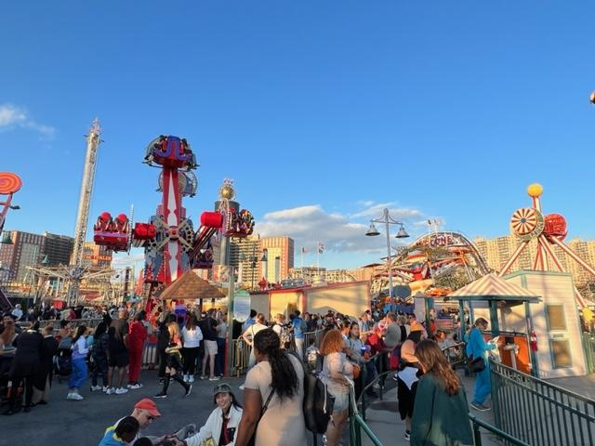
Luna Park Halloween weekend 2023

The park was busy with patrons visiting for the “Harvest Fall Fest”, a Halloween themed event that attracted many families and quite a few tourists from Manhattan as I heard people talk about how long the trip was to Coney Island. Families were engaging in all the rides, the activities such as the hay maze, pumpkin painting and enjoying the rides. Luna Park wa packed with people and it was extremely busy in all partx of the park and on the Boardwalk as well.
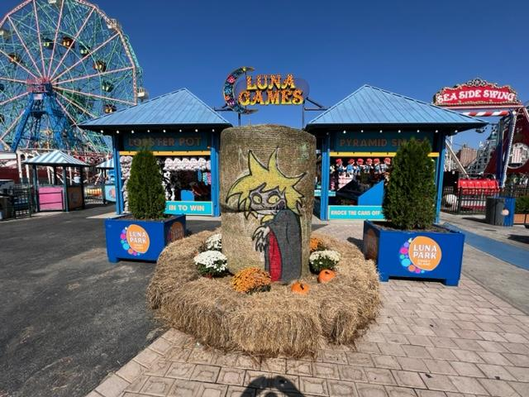
The “Fall Fest” decorations of Luna Park
As part of our experience in the park, two of us rode the Cyclone first and that is always a great experience especially on a sunny day. As you make the first tune, you almost feel like you are going to fly in the ocean. I think it was originally designed to make you feel that way. The twists and turns of the oldest wooden roller coaster in the country is one of its charms. We flew back and forth and yelled with everyone else on the coaster.
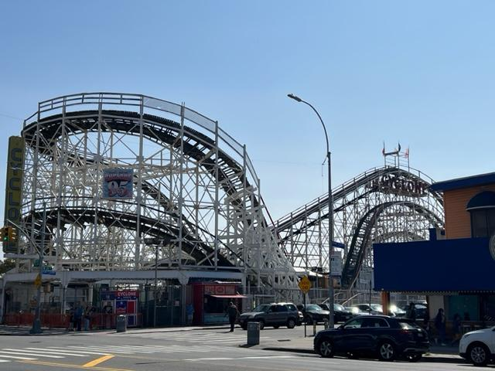
The Cyclone Roller Coaster is the most famous ride in Coney Island.
After the Cyclone, lunch was the next thing on your agenda as we were both hungry. We tried the pizzeria in the main section of the kiddie rides and the slices of pizza were pretty good. They had a nice taste and were just above a good frozen pizza but not quite gourmet. The slices were very generous and well worth the price. It was not a restaurant we would return to in the future as Nathan’s or Tortuno’s Pizza on Neptune Avenue would be more of a choice. Gargiulo’s right down the block is better for Italian food. For amusement park food though it was very good.
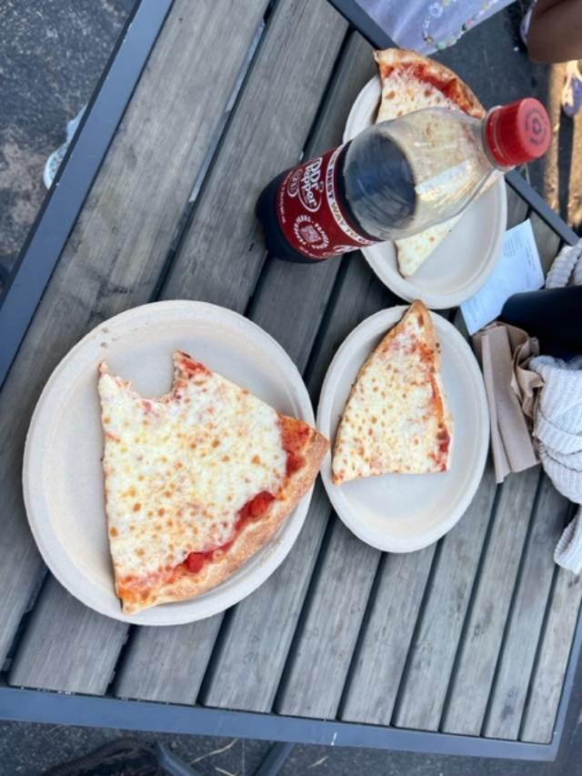
The food and the service were quite good at the park.
Our next ride was the historic Carousel on the edge of the park near the Parachute Jump (this was closed during the “Frost Fest”). It is a beautiful old Carousel and the carving were very interesting. The problem with the ride was that for $4.00 per person there was no music and it made only four rotations. The ride could have been a bit longer.
While we visited the different sections of the park, the two of us engaged with the staff both on the rides and at the pizzeria. I thought they could be a bit abrupt but then this is Brooklyn, not the Jersey Shore and the staff was hired locally from Coney Island, which has a diverse and tough attitude. You must understand the people from Brooklyn. It can be off-putting to people who do not know Brooklyn that well. Still, I thought everyone we talked to was very nice. They could have had some consistency in their grooming. This is where a Dress Code becomes important to give a consistent look in the park.
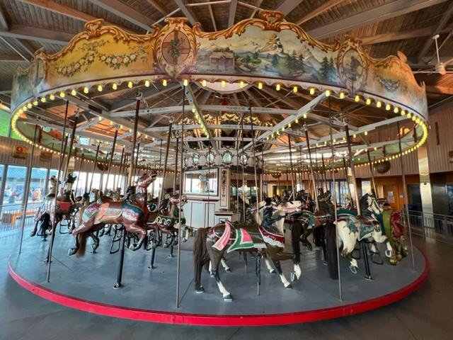
The famous “B & B” Carousel in Luna Park
The park continued to be busy all through the time we visited and got busier when the sun went down. People were really enjoying the warm weather and it must have been in the 60’s by the time the sun went down. We walked the entire length of the Boardwalk even past the amusements into Brighten Beach and Manhattan Beach where the Boardwalk ended. This was dominated by families and lots of kids running around the Boardwalk. With a large Russian/Slavonic population, the restaurants cater to the local neighborhood crowd.
When we returned to the amusement section of the Boardwalk, it was still in full swing with colorful lights, music, laughter and screaming from people riding the coasters late into the evening. It can be quite magical at night from a distance and up close if you really look at it. We had a nice time on the October afternoon.
Luna Park at night when the magic happens.
When we returned for “Frost Fest” three weeks later a gloomy Saturday afternoon, it was a different story. With the threat of rain, the park was rather quiet in the morning. The three of us from the Team met on a misty and gray day and it threatened to rain most of the time.
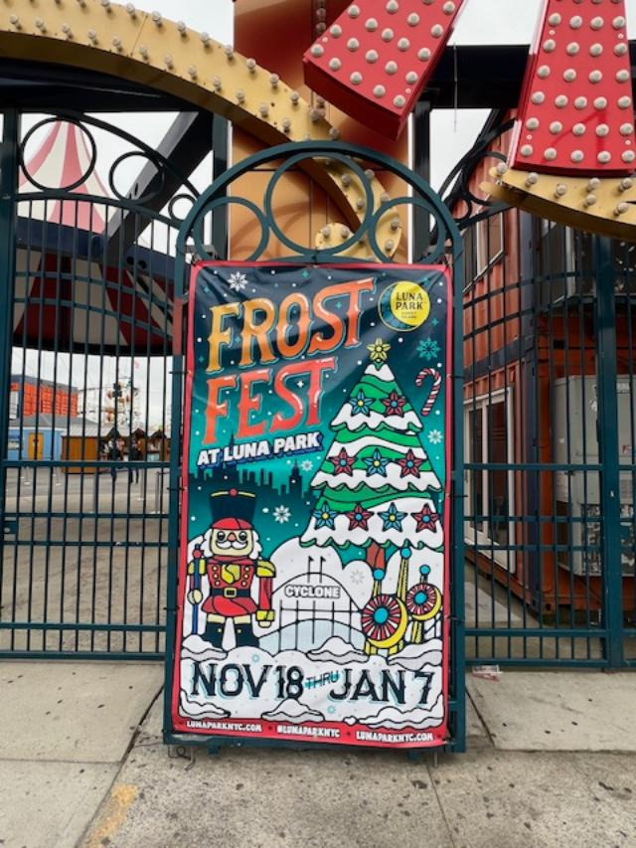
The first Annual “Frost Fest” in 2023.
The three of us walked the park and discovered that “Frost Fest” only consisted of the larger, kiddie section of the park. The water rides, the carousel and go cart rides in the other two sections of the park were closed.
The main part of the park was very festive. There was a large Christmas tree at the entrance of the park and a Santa’s Village set up with different stands selling seasonal treats like hot chocolate, fresh doughnuts, and assorted fried items such as funnel cakes. There was a place to visit Santa but the rain threatened us. So, two of us rode the Cyclone again (which is never dull) and we all decided to leave the park before it rained. By the time we got to the subway, it poured and poured for the rest of the afternoon.
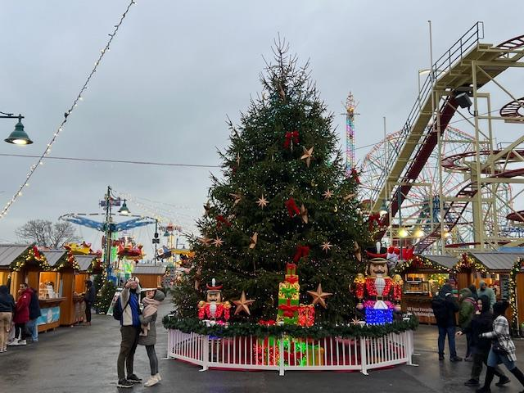
The Christmas tree at the “Frost Fest” at Luna Park
On another visit, two Team members went on a rainy Sunday that got worse and were not able to enter the park. Security guards met guests at the front gate letting patrons know that the park was closed for the day because of the weather. Both mentioned how disappointed they were about not being able to enjoy the rides. One observation that one Team member made was that this could have been an opportunity to promote their indoor activities of the arcade and one of the foodservice outlets.
They both commented on how the better use of social media and the park’s website could have let people know that the park was closed for the day. This had not been on the site when they left for the park. The park security guards could have also been a bit nicer to the patrons who were arriving at the park that day. As an outdoor park, this might be an opportunity in the future for the park to partner with the New York Aquarium and the Coney Island Museum to spread that holiday cheer to other parts of the amusement zone when the weather is bad.
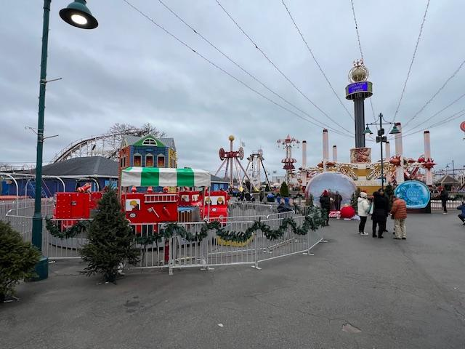
An amusement park is not fun on a gloomy day. Promoting indoor events could help with the business.
On a nicer day, the park can be quite pleasant. At twilight, the rides are lit with white Christmas lights and the tree was lit before we left so we saw the faint lights come on. It was a good first attempt that they kept the park open this late into the year. Just like any outdoor park, it is the victim to the whims of the weather.
The Rating Scale and Criteria Justification:
The “Eight Point System” was established to better judge the park as a guest visiting the park for the first time. We wanted to set a point of origin such as Manhattan where most people stay and take it from the perspective of what most tourists feel an amusement park should offer. We looked at the Point System from the aspect from travel to arrival in Coney Island and then walking from the subway to the park. Once entering the park, how did it make the guest feel and what type of experience did they expect from the park now that they had arrived.
While the park is not Disneyland, Luna Park should have a sense of fun and excitement. The problem with any outdoor activity is that the success of the park is based solely on the weather. Luna Park does not have many indoor attractions outside the B & B Carousel. The added theme events such as “Frost Fest” and “Harvest Fest” should have added more decorations, seasonal foods and an entertainment schedule including bands and/or fireworks to open these events. The “Eight Point System” is judged on a scale of one to ten.
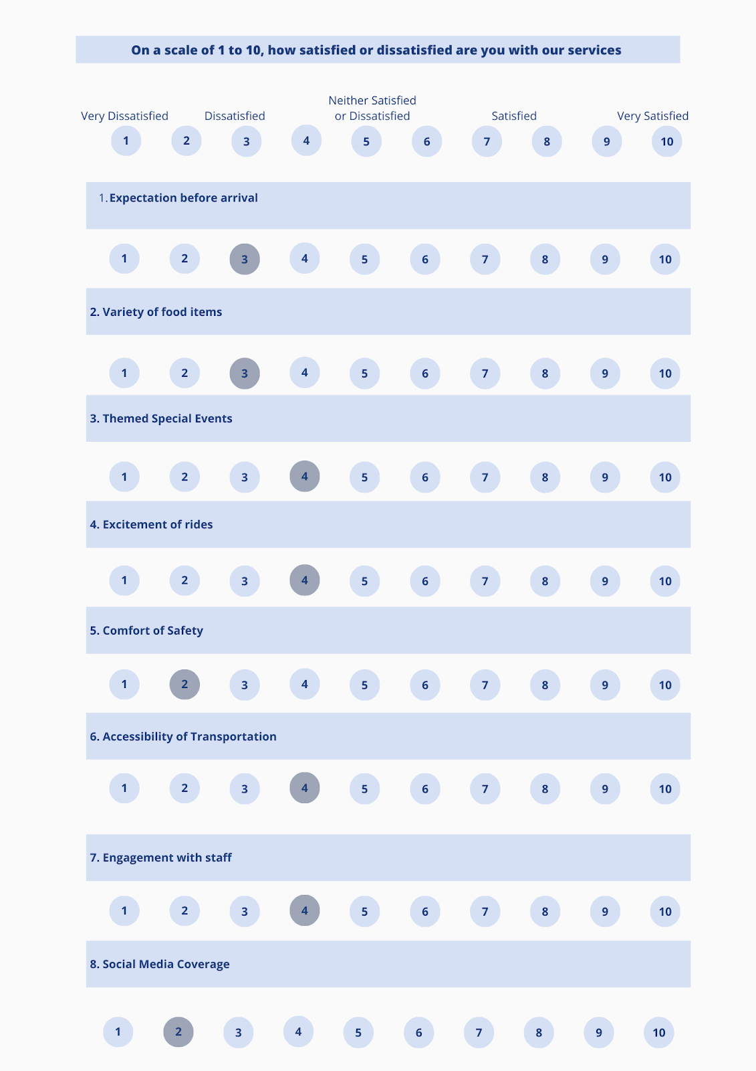
The” Eight Point Scale” we established from the impression of each of our visits to the park.
The Eight Point Scale of the Experience of visiting Luna Park:
- Expectations before Arrival to Luna Park:
The anticipation of visiting Luna Park was fueled by a desire for an all-encompassing amusement experience is what we looked forward to when first visiting Luna Park. We envisioned a diverse, fun-filled afternoon of rides and attractions and those expectations were set very high before setting foot into the park itself. We thought there would be a park layout that conveyed orderliness and coherence and eluded a sense of fun and excitement.
Upon arriving at Luna Park multiple times over the fall season, there was a sense of disappointment in the visitation to the park. While there has been strides made since the days of the old “Astroland Park,” Luna Park’s offerings appeared to be centered mostly around children, leaving scant choices for adult thrill seekers aside from the Cyclone and Carousel (the Thunderbolt was closed both times we visited).
Before the visit, we had the typical expectations of a secure environment, organized crowd management and distinct gates that bounded the park. Anticipating an entrance fee and facilities that secured entry points, this is where the park fell short of our expectations. Luna Park appeared to lack essential resources expected in a conventional amusement park, most notably secured in and out gates and organized customer flow management.
The reputation of Luna Park with its visions of grand towers lit into the night, minarets and spirals are part of the park’s past. That was the old Luna Park. Despite the deviations from the expectations, Luna Park’s unique charms and potential for growth remain apparent to all of us. This is a park of the future where with a few mature adult rides and more visual security staff at the check points can establish a new reputation of fun and engagement with guests from all over the world.

- Variety of Food Service Options:
The selection of Culinary offerings was limited to the usual amusement/carnival food selections of hamburgers, hot dogs, French fries, and pizza. For desserts, there were the choices of fresh doughnuts, funnel cakes and ice cream. These are the perfect items for a fussy child after a day at the park but redundant for adults. The selection was tailored for a younger audience who dominate the park. The familiarity of the fare provided comfort but left room for innovation and thematic additions. During the recent theme events of “Harvest Fest” for the Halloween holidays and “Frost Fest” for the Christmas holiday season could have provided a wider variety of sandwich and dessert options. The cooler months needs a heartier menu. Still, when dining at the pizzeria in the park, the portion sizes were very generous and in line with the prices.
The pizza was very good at the park’s pizzeria
- Themed Special Events:
The “Harvest Festival” was a fall spectacle adorned with intricately detailed decorations evoking the autumn festivals of the past with hay stacks and pumpkins adding to the seasonal charm of the park. The park was transformed with colorful displays and Halloween-themed embellishments that dotted the park. With children’s hayrides and pumpkin painting, these family friendly events made for the perfect outing especially Halloween weekend when it was 81 degrees. The park was packed with families having a good time.
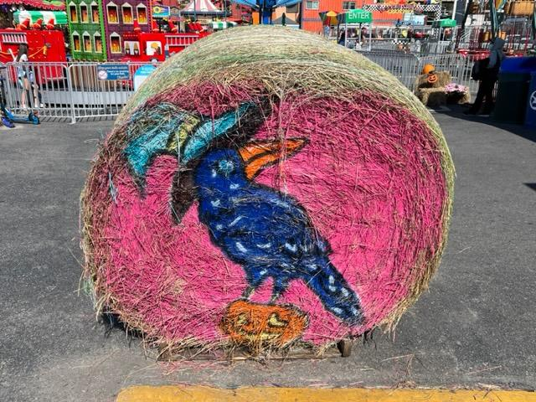
The creative decorations on Halloween weekend added to the fun of the park.
The “Frost Fest” was the park’s first attempt to stretch the park’s season into the Christmas holiday season with elaborate displays, a large Christmas tree at the entrance and a Santa Village selling everything from hot chocolate and smores to fresh doughnuts and funnel cakes at the stands. This wintery spectacle was teeming with holiday cheer. The allure of the Santa photo experience, coupled with Rudolph’s Rink, an eco-conscious skating venture, immerses visitors in a magical ambience, allowing them to revel in the festivities despite the cold.
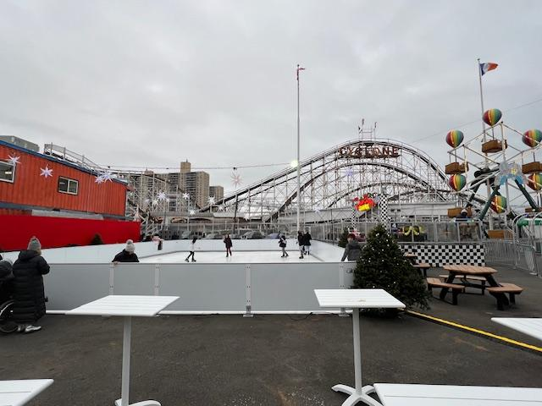
The “Rudolph’s Rink” at Luna Park
Reflecting on Luna Park’s themed events, the consensus among us was varied. Some of the selections at the park can be found in any suburban town or farm for the fall season but can be added on to in the future with a few adjustments. The new “Frost Fest” breathed newfound vigor and excitement into Luna Park, surpassing previous years offering. We must see at the of the season the success of the event especially with the current weather conditions.
While “Frost Fest’s Christmas tree novelty in the park should be commended some of the decorations lacked the intricacy in certain areas, requiring additional embellishments in the future. We will need to visit Santa in the future. The need for more elaborate decorations and improved guidance during these events, it urges the park’s organizers to collaborate with a partnership both with local cultural sites like the NY Aquarium, the Coney Island Museum and with the City by decorating the Boardwalk for the holidays would add enhanced appearance and clearer directions for the events.
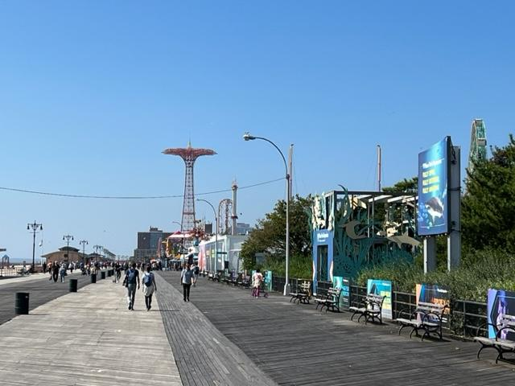
Decorating the popular Boardwalk and NY Aquarium would spread the holiday spirit throughout the Coney Island amusement zone.
- Excitement of the Rides:
As a Team, our excursions to Luna Park stirred a variety of impressions and reactions toward the park. Both with excitement and apprehension regarding the park’s array of rides and attractions there was mixed feelings. With a diverse attitude of experiences, this painted a nuanced picture of the park, reflecting differing views and emotions among the Team members.
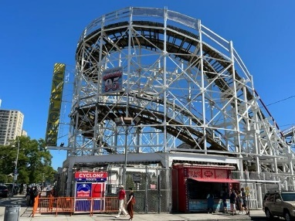
The famous Cyclone Roller Coaster
The Cyclone is a beacon of nostalgia and thrill for many, it evoked mixed feelings within our Team. While some of us found joy in the ride’s excitement and thrill, others yearned for a longer journey. With the Carousel, we liked the ride’s simplicity and charm, we yearned for a longer journey on the ride with melodic tunes and twinkling lights. We expressed disappointment in the absence of accompanying music.
Our collective opinion also touched the access to the rides, noting discrepancies where certain attractions like the Ferris Wheel and Carousel were not included in the wristband offerings. This caused disappointment among the Team members and limiting access to these specific rides.
- Comfort of Safety:
While the individual experiences differed, a consensus emerged regarding the need for heightened security measures. Despite some Team members expressing the feeling generally secure within the park, concerns persisted about the open entry points and the apparent absence of consistent security personal, leaving the gaps that could potentially compromise visitor safety.
Suggestions for improved safety precautions were voiced, including the implementation of security guards, metal detectors at entrances and a more robust surveillance infrastructure to mitigate potential incidents and vandalism within the park especially in the bathrooms.
- Accessibility of Transportation:
Some of the Team members noted that Luna Park’s perceived distance from New York City’s primary attraction areas, possibly deterring visitors from seeking closer amusement alternatives with the core City limits. For some Team members residing in Manhattan, the commute to Luna Park presented as a considerable distance, spanning approximately an hour and a half via the subway. This distance, while feasible, was perceived as a significant trek, posing a challenge for those seeking a closer entertainment destination.
Contrasting perspectives emerged regarding accessibility. The park’s location, serviced by multiple subway lines such as the D, F, N, R, and Q lines, along several bus routes, offered convenience and ease of access for visitors using public transportation. The distance from the subway station was particularly commended.
- Engagement with the Staff:
The interaction with the staff generated a range of experiences. While some Team members praised the friendly and engaging nature of the staff, others highlighted a need for a more professional approach. Feedback highlighted instances of casual conversational approaches, with suggestions for a more standardized, professional interaction, especially concerning customers engagement training for consistent communication.
Amidst these varying perspectives, certain team members acknowledged the overall friendliness and willingness of the staff to assist visitors, creating a positive engagement atmosphere. Professionalism, friendliness, and training received a commendation, signifying instances where staff interaction met or exceeded expectations.
The inconsistency in staff demeanor surfaced as a recurrent theme, echoing sentiments found in TripAdvisor reviews that mirrored some of our Team’s observations. The spectrum of experiences showcased the challenge of reconciling a city-oriented mentality with out-of-town visitors’ expectations creating a disparity in the perception of staff interactions.
- Social Media Coverage:
While Luna Park is a gem nestled within New York City, our team collectively noted a deficiency in proactive promotion. Despite having a presence on Instagram and YouTube, the updates lacked the spark needed to evoke a sense of exclusivity, rendering the publicity somewhat lackluster and failing to harness the park's unique essence.
The park's attempt to leverage social media for the Frost Festival fell short, with content lacking the magnetism required for heightened consumer interaction and participation. Observations revealed a consistent yet uninspiring approach, hampering the engagement potential on these platforms.
Instances where Luna Park's social media engagement felt inadequate surfaced among team members, with observations indicating a need for stronger collaborations with New York City's Tourism and Conventions, seeking more significant exposure on prominent platforms to bolster visibility.
Critical feedback highlighted the sporadic and underwhelming nature of Luna Park's social media updates, lacking the regularity, engaging content, and cohesive promotional strategy necessary to captivate prospective visitors. The sporadic nature of posts failed to stimulate interest or effectively promote the park's offerings and events.
Recommendations from the team converge on the need for an active, strategic overhaul of Luna Park's social media approach. Suggestions include leveraging platforms like Instagram, TikTok, and Facebook to showcase the park's unique attractions, curate interactive content, and foster direct engagement with followers, thereby enhancing visibility and generating interest among potential visitors.
Despite varying opinions, certain team members acknowledged Luna Park's active presence on Instagram, appreciating the park's efforts in maintaining an engaging profile and interacting with customers, a facet not fully reflected in certain online reviews.

G. Rating of the experience
Our team's collective excursion to Luna Park unveiled an array of diverse experiences and perspectives, resonating with both moments of delight and areas of opportunity. As individuals with distinct expectations, our journey to this amusement haven conjured mixed sentiments and reflections, shaping our overall evaluation.
For some among us, initial anticipation paved the way for mild disappointment upon arrival. The journey to Luna Park proved lengthy, spanning an hour and a half, setting an underwhelming tone. Subsequent encounters within the park raised concerns about the perceived age and safety of certain amusement facilities, fostering hesitancy among potential riders. The limited food options and perceived lack of security presence added further reservations, casting shadows over the overall safety and variety of offerings.
However, amidst these concerns, some team members highlighted positive aspects. The park's appeal to families with young children stood out, offering a range of attractions suited to their needs. While certain rides were closed or limited due to weather or maintenance, the overall experience was enjoyable, particularly for thrill-seekers and families.
The impact of weather on the visitor experience emerged as a significant factor, with varying impressions based on climate conditions. Gloomy weather led to a less favorable experience, evoking concerns about outdoor equipment and potential safety issues. Conversely, on sunny days, the park exuded a more inviting ambiance, elevating the overall enjoyment, complemented by friendly staff interactions and culinary delights.
Observations on themed events like Frost Fest and Harvest Festival were met with both appreciation and suggestions for enhancement. While these events extended the park's seasonal offerings, some team members highlighted potential for more elaborate decorations and expanded winter-themed activities to further enrich the visitor experience.

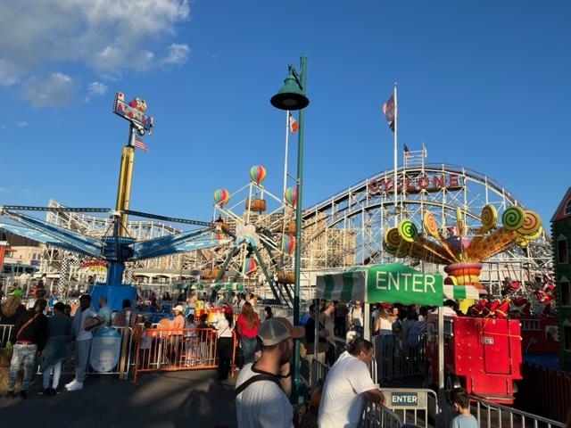
Luna Park during the “Harvest Festival”
H. Improving the Customer Experience at Luna Park

Leveraging Technology

1. Implement an easy-to-use park mobile app with features like interactive maps, ride wait times, virtual queuing for rides, mobile food ordering from park restaurants, and ticket purchasing/scanning. Offer exclusive mobile discounts and personalized push notifications based on preferences.

2. Install a network of digital screens across the park displaying real-time information on wait times, daily schedules, special events, and promotional offers. Strategically place screens at ride queues, rest areas, and food locations.

3. Introduce augmented reality games and immersive experiences through the app that visitors can enjoy around the park. This could include scavenger hunts, trivia games, or taking photos with virtual mascots.

4. Expand online merchandise shopping through the app to allow visitors to purchase park-themed souvenirs anytime, even after leaving the park. Offer free shipping or in-park pickup.

Enhancing Service and Engagement

1. Implement a customer service training program focused on delivering excellent service with a welcoming, enthusiastic, and helpful attitude. Provide ongoing training refreshers. Incentivize employees for great reviews or customer compliments.

2. Offer small welcome packages or gifts to visitors upon park entry like food/merchandise vouchers or collectible pins to delight first-time visitors and get them excited about their day.

3. Actively post and share engaging, visually appealing content on social media platforms showcasing new park attractions, behind-the-scenes details, visitor experiences, upcoming events/shows, and more. Respond to comments and inquiries.

4. Designate branded hashtags and encourage visitors to share their park photos, videos, and experiences on social media through contests or incentives. Repost user-generated content.

Improving Infrastructure

1. Enhance security through measures like designated park entry points, increased visibility of security personnel, implementation of foot and vehicle patrols, and security camera installation across high traffic areas of the park.

2. Set grooming, wardrobe, and presentation standards for all customer-facing park staff. Conduct periodic evaluations.

3. Maintain cleanliness across the park by having staff regularly walk around and inspect restrooms, dining areas, queues, and common spaces. Continuously restock restroom supplies like soap and paper products. Remove graffiti from the bathrooms walls when it appears.

Personalization and Customization

1. Collect visitor data like mailing lists, survey responses, and app activity to provide personalized and tailored recommendations, communication via emails or push notifications, and special offers based on expressed interests, past purchases, and previous park interactions.

Feedback and Improvements

1. Gather visitor feedback in real-time by sending in-app surveys during or immediately after park visits. Offer incentives like discounts on return visits or merchandise for completing the surveys.

2. Regularly review visitor feedback insights and swiftly address areas needing improvement. Communicate changes or improvements to visitors to demonstrate responsiveness.

Partnerships

1. Partner with city tourism organizations for cross-promotion of the park through advertising campaigns, ticket giveaways, and inclusion in tourist recommendations.

2. Coordinate seasonal events, holiday overlays, decorations, and festivities with local Coney Island stakeholders to enhance the area's visitor appeal.

3. Partner with other cultural institutions within the amusement area during holiday t heme events to ensure that there will be indoor activates due to inclement weather.

Works Cited:
Kyriazi, Gary. “The Great American Amusement Parks: A Pictorial History.” PP. 57-71. Castle Books. 1971.
Historical Luna Park Pictures. New York Historical Society, New York, NY. 2023 https://www.nyhistory.org/
Current Coney Island pictures. MywalkinManhattan.com, Justin Watrel. 2023 https://mywalkinmanhattan.com/
New York City Tourism+Conventions website. 2023 https://www.nyctourism.com/
Wiki. Astroland History. 2023 https://en.wikipedia.org/wiki/Astroland
History of Coney Island. Senior Thesis. Justin Watrel. Hunterdon Central High School. 1983.
Personal Visit to the park with Luna Park Operations Manager Bryant Alberto with the Team.10/14/2023.
Personal Visits by each Team member to Luna Park. October and November 2023.
Central Amusement International website. Logo. 2023 https://www.linkedin.com/company/central-amusement-international/

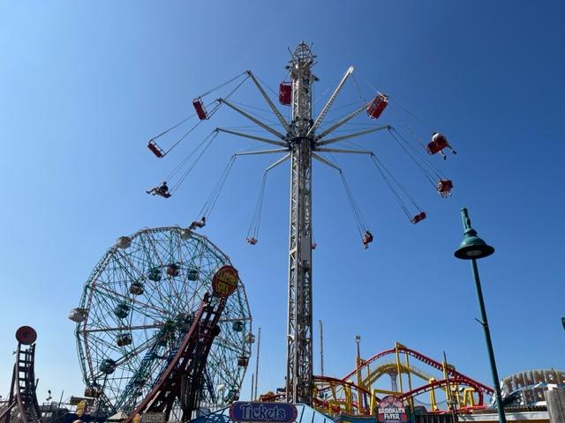
The amusements of Luna Park.

